First Come First Serve Scheduling:

// C++ program for implementation of FCFS
// scheduling with different arrival time
#include<iostream>
using namespace std;

// Function to find the waiting time for all
// processes
void findWaitingTime(int processes[], int n, int bt[],
int wt[], int at[])
{
int service_time[n];
service_time[0] = 0;
wt[0] = 0;

// calculating waiting time
for (int i = 1; i < n ; i++)
{
// Add burst time of previous processes
service_time[i] = service_time[i-1] + bt[i-1];

// Find waiting time for current process =
// sum - at[i]
wt[i] = service_time[i] - at[i];

// If waiting time for a process is in negative
// that means it is already in the ready queue
// before CPU becomes idle so its waiting time is 0
if (wt[i] < 0)
wt[i] = 0;
}
}

// Function to calculate turn around time
void findTurnAroundTime(int processes[], int n, int bt[],
int wt[], int tat[])
{
// Calculating turnaround time by adding bt[i] + wt[i]
for (int i = 0; i < n ; i++)
tat[i] = bt[i] + wt[i];
}

// Function to calculate average waiting and turn-around
// times.
void findavgTime(int processes[], int n, int bt[], int at[])
{
int wt[n], tat[n];

// Function to find waiting time of all processes
findWaitingTime(processes, n, bt, wt, at);

// Function to find turn around time for all processes
findTurnAroundTime(processes, n, bt, wt, tat);

// Display processes along with all details
cout << "Processes " << " Burst Time " << " Arrival Time "
<< " Waiting Time " << " Turn-Around Time "
<< " Completion Time \n";
int total_wt = 0, total_tat = 0;
for (int i = 0 ; i < n ; i++)
{
total_wt = total_wt + wt[i];
total_tat = total_tat + tat[i];
int compl_time = tat[i] + at[i];
cout << " " << i+1 << "\t\t" << bt[i] << "\t\t"
<< at[i] << "\t\t" << wt[i] << "\t\t "
<< tat[i] << "\t\t " << compl_time << endl;
}

cout << "Average waiting time = "
<< (float)total_wt / (float)n;
cout << "\nAverage turn around time = "
<< (float)total_tat / (float)n;
}

// Driver code
int main()
{
// Process id's
int processes[] = {1, 2, 3};
int n = sizeof processes / sizeof processes[0];

// Burst time of all processes
int burst_time[] = {5, 9, 6};

// Arrival time of all processes
int arrival_time[] = {0, 3, 6};

findavgTime(processes, n, burst_time, arrival_time);

return 0;
}

OUTPUT:

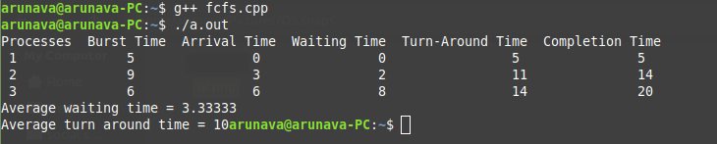

Shortest Job First Scheduling:

// C++ program to implement Shortest Job first with Arrival Time
#include<iostream>
using namespace std;
int mat[10][6];

void swap(int *a, int *b)
{
int temp = *a;
*a = *b;
*b = temp;
}

void arrangeArrival(int num, int mat[][6])
{
for(int i=0; i<num; i++)
{
for(int j=0; j<num-i-1; j++)
{
if(mat[j][1] > mat[j+1][1])
{
for(int k=0; k<5; k++)
{
swap(mat[j][k], mat[j+1][k]);
}
}
}
}
}

void completionTime(int num, int mat[][6])
{
int temp, val;
mat[0][3] = mat[0][1] + mat[0][2];
mat[0][5] = mat[0][3] - mat[0][1];
mat[0][4] = mat[0][5] - mat[0][2];

for(int i=1; i<num; i++)
{
temp = mat[i-1][3];
int low = mat[i][2];
for(int j=i; j<num; j++)
{
if(temp >= mat[j][1] && low >= mat[j][2])
{
low = mat[j][2];
val = j;
}
}
mat[val][3] = temp + mat[val][2];
mat[val][5] = mat[val][3] - mat[val][1];
mat[val][4] = mat[val][5] - mat[val][2];
for(int k=0; k<6; k++)
{
swap(mat[val][k], mat[i][k]);
}
}
}

int main()
{
int num, temp;

cout<<"Enter number of Process: ";
cin>>num;

cout<<"...Enter the process ID...\n";
for(int i=0; i<num; i++)
{
cout<<"...Process "<<i+1<<"...\n";
cout<<"Enter Process Id: ";
cin>>mat[i][0];
cout<<"Enter Arrival Time: ";
cin>>mat[i][1];
cout<<"Enter Burst Time: ";
cin>>mat[i][2];
}

cout<<"Before Arrange...\n";
cout<<"Process ID\tArrival Time\tBurst Time\n";
for(int i=0; i<num; i++)
{
cout<<mat[i][0]<<"\t\t"<<mat[i][1]<<"\t\t"<<mat[i][2]<<"\n";
}

arrangeArrival(num, mat);
completionTime(num, mat);
cout<<"Final Result...\n";
cout<<"Process ID\tArrival Time\tBurst Time\tWaiting Time\tTurnaround Time\n";
for(int i=0; i<num; i++)
{
cout<<mat[i][0]<<"\t\t"<<mat[i][1]<<"\t\t"<<mat[i][2]<<"\t\t"<<mat[i][4]<<"\t\t"<<mat[i][5]<<"\n";
}
}

OUTPUT:

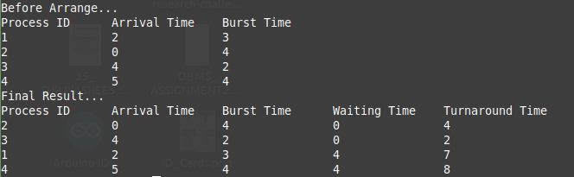

Priority Scheduling:

// C++ program for implementation of Priority
// scheduling
#include<bits/stdc++.h>
using namespace std;

struct Process
{
int pid; // Process ID
int bt; // CPU Burst time required
int priority; // Priority of this process
};

// Function to sort the Process acc. to priority
bool comparison(Process a, Process b)
{
return (a.priority > b.priority);
}

// Function to find the waiting time for all
// processes
void findWaitingTime(Process proc[], int n,
int wt[])
{
// waiting time for first process is 0
wt[0] = 0;

// calculating waiting time
for (int i = 1; i < n ; i++ )
wt[i] = proc[i-1].bt + wt[i-1] ;
}

// Function to calculate turn around time
void findTurnAroundTime( Process proc[], int n,
int wt[], int tat[])
{
// calculating turnaround time by adding
// bt[i] + wt[i]
for (int i = 0; i < n ; i++)
tat[i] = proc[i].bt + wt[i];
}

//Function to calculate average time
void findavgTime(Process proc[], int n)
{
int wt[n], tat[n], total_wt = 0, total_tat = 0;

//Function to find waiting time of all processes
findWaitingTime(proc, n, wt);

//Function to find turn around time for all processes
findTurnAroundTime(proc, n, wt, tat);

//Display processes along with all details
cout << "\nProcesses "<< " Burst time "
<< " Waiting time " << " Turn around time\n";

// Calculate total waiting time and total turn
// around time
for (int i=0; i<n; i++)
{
total_wt = total_wt + wt[i];
total_tat = total_tat + tat[i];
cout << " " << proc[i].pid << "\t\t"
<< proc[i].bt << "\t " << wt[i]
<< "\t\t " << tat[i] <<endl;
}

cout << "\nAverage waiting time = "
<< (float)total_wt / (float)n;
cout << "\nAverage turn around time = "
<< (float)total_tat / (float)n;
}

void priorityScheduling(Process proc[], int n)
{
// Sort processes by priority
sort(proc, proc + n, comparison);

cout<< "Order in which processes gets executed \n";
for (int i = 0 ; i < n; i++)
cout << proc[i].pid <<" " ;

findavgTime(proc, n);
}

// Driver code
int main()
{
Process proc[] = {{1, 10, 2}, {2, 5, 0}, {3, 8, 1}};
int n = sizeof proc / sizeof proc[0];
priorityScheduling(proc, n);
return 0;
}

OUTPUT:

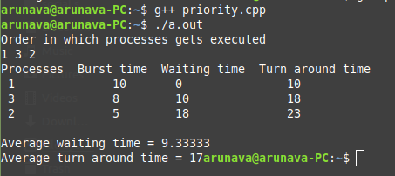

Roundrobin Scheduling:

// C++ program for implementation of RR scheduling
#include<iostream>
using namespace std;

// Function to find the waiting time for all
// processes
void findWaitingTime(int processes[], int n,
int bt[], int wt[], int quantum)
{
// Make a copy of burst times bt[] to store remaining
// burst times.
int rem_bt[n];
for (int i = 0 ; i < n ; i++)
rem_bt[i] = bt[i];

int t = 0; // Current time

// Keep traversing processes in round robin manner
// until all of them are not done.
while (1)
{
bool done = true;

// Traverse all processes one by one repeatedly
for (int i = 0 ; i < n; i++)
{
// If burst time of a process is greater than 0
// then only need to process further
if (rem_bt[i] > 0)
{
done = false; // There is a pending process

if (rem_bt[i] > quantum)
{
// Increase the value of t i.e. shows
// how much time a process has been processed
t += quantum;

// Decrease the burst_time of current process
// by quantum
rem_bt[i] -= quantum;
}

// If burst time is smaller than or equal to
// quantum. Last cycle for this process
else
{
// Increase the value of t i.e. shows
// how much time a process has been processed
t = t + rem_bt[i];

// Waiting time is current time minus time
// used by this process
wt[i] = t - bt[i];

// As the process gets fully executed
// make its remaining burst time = 0
rem_bt[i] = 0;
}
}
}

// If all processes are done
if (done == true)
break;
}
}

// Function to calculate turn around time
void findTurnAroundTime(int processes[], int n,
int bt[], int wt[], int tat[])
{
// calculating turnaround time by adding
// bt[i] + wt[i]
for (int i = 0; i < n ; i++)
tat[i] = bt[i] + wt[i];
}

// Function to calculate average time
void findavgTime(int processes[], int n, int bt[],
int quantum)
{
int wt[n], tat[n], total_wt = 0, total_tat = 0;

// Function to find waiting time of all processes
findWaitingTime(processes, n, bt, wt, quantum);

// Function to find turn around time for all processes
findTurnAroundTime(processes, n, bt, wt, tat);

// Display processes along with all details
cout << "Processes "<< " Burst time "
<< " Waiting time " << " Turn around time\n";

// Calculate total waiting time and total turn
// around time
for (int i=0; i<n; i++)
{
total_wt = total_wt + wt[i];
total_tat = total_tat + tat[i];
cout << " " << i+1 << "\t\t" << bt[i] <<"\t "
<< wt[i] <<"\t\t " << tat[i] <<endl;
}

cout << "Average waiting time = "
<< (float)total_wt / (float)n;
cout << "\nAverage turn around time = "
<< (float)total_tat / (float)n;
}

// Driver code
int main()
{
// process id's
int processes[] = { 1, 2, 3};
int n = sizeof processes / sizeof processes[0];

// Burst time of all processes
int burst_time[] = {10, 5, 8};

// Time quantum
int quantum = 2;
findavgTime(processes, n, burst_time, quantum);
return 0;
}

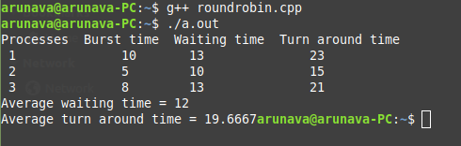
OUTPUT:

